**GREEN LANTERN FINALS PROJECT**

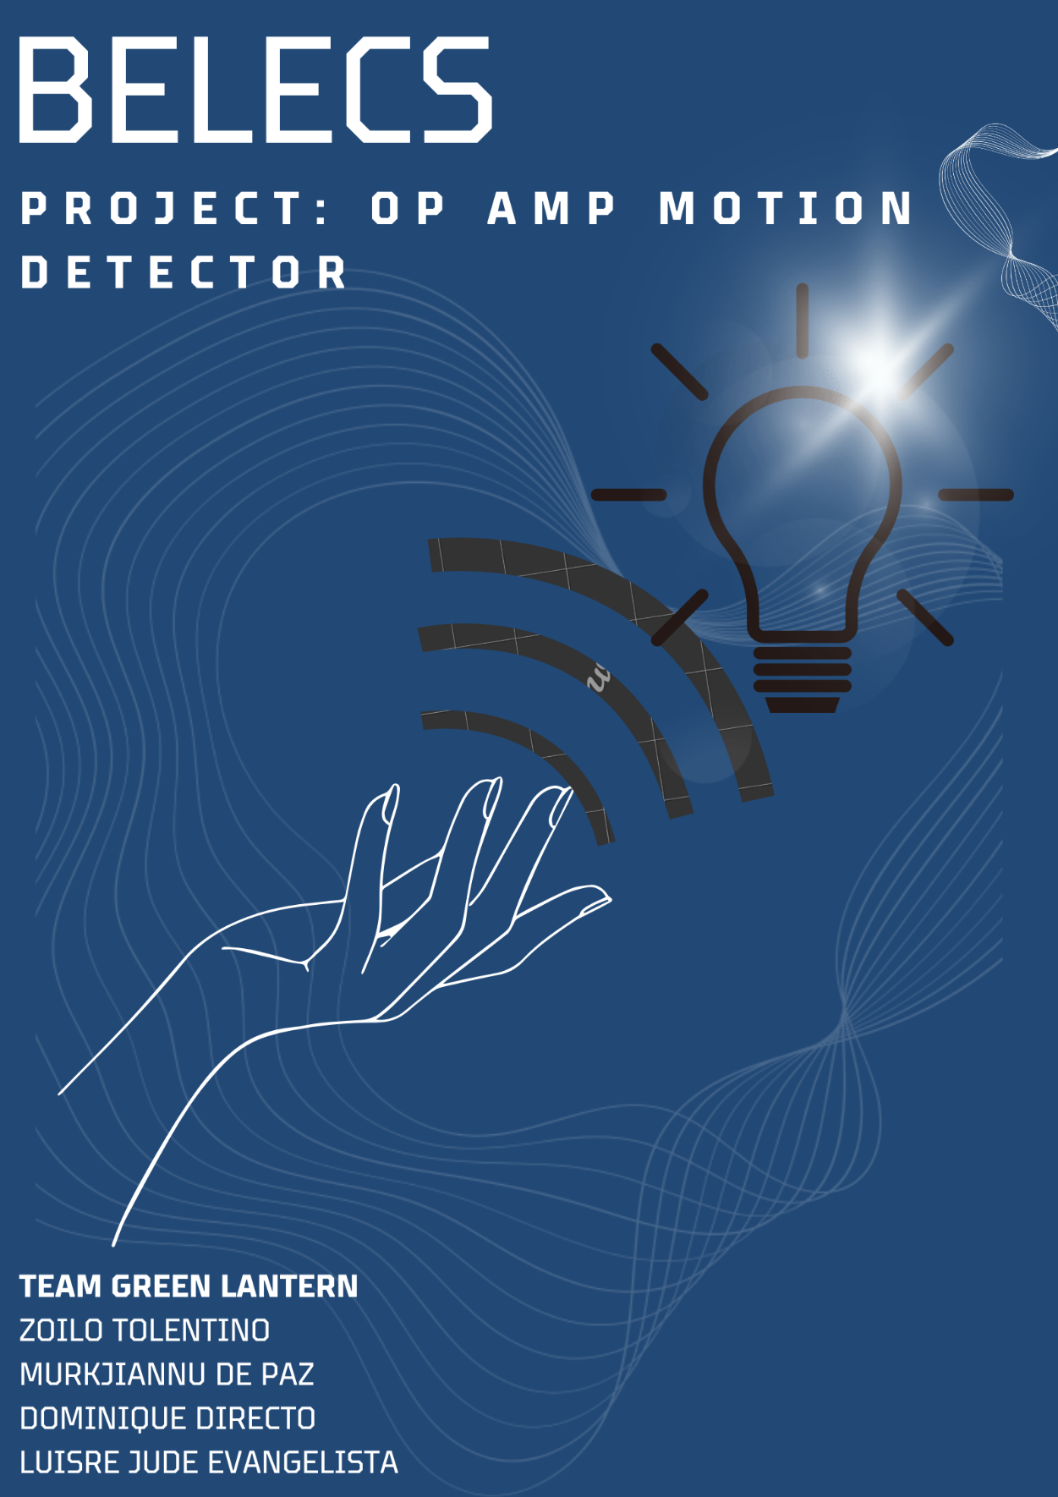

**LINK TO VIDEO:** <https://www.youtube.com/watch?v=PLj-xmEBhtY&t=11s>

